- BASIC DEPARTMENT INFORMATION

  - Department name: Mechanical engineering
  - Year of establishment: 1999
  - HOD name: Dr S Arumugam



  - Department vision and mission

VISION: To be a prominent Centre of Excellence in the field of Mechanical Engineering, where teaching, learning, and research synergize to convey technical education and scientific research for public good.

MISSION

- To achieve academic excellence in engineering through commitment to duty, innovation in teaching to enhance human values.
- To enable our students to develop into outstanding professionals with high moral standards to face the challenges of the next millennium.
- To fulfil the expectation of our society by equipping our students to stride forth as resourceful citizens aware of their immense responsibility to make the world a better place.

Unique features of the Department
- Faculty with Ph. D qualification
- Classrooms with ICT facilities
- State-of-the-art laboratories
- Advanced Research facilities

- COURSES OFFERED
Under Graduate Programme
- B.E – Mechanical Engineering (FT) in Specialisation with 3D Printing/Electric Vehicle/Robotics,
Duration: 4 yrs, Age: Maximum age (Full-time): 20 years
- B.E – Mechanical Engineering (PT)
Duration: 3½ yrs - No age limit
Other Minor Degree Specializations - Universal Human Values/Artificial Intelligence & Machine Learning/Data Science/Cyber Security/Internet of Things/VLSI Design/5G Communication/Image Processing & Computer Vision/Sensor Technology/Microgrid Technology/Electrical & Computer Science
- Post Graduate Programmes
- ME – Engineering Design (FT)
Duration: 2 Yrs
- ME – Engineering Design (PART-TIME)
Duration: 3 Yrs, No age limit
- Research Programmes
  - Ph.D (FT)
Duration: 2 yrs min.
  - Ph.D (PT)
Duration: 3 yrs maximum up to 6 yrs

Carrer opportunities
- Government and public sector companies in the field of Mechanical Engineering
- Machinery and manufacturing
- Automobile and automation industries
- Design, R&D,, and energy sectors

Industry relevance
- Design and optimization of machines, tools, and production systems.
- Automation, robotics, and quality control
- Vehicle design, engine development, transmission systems
- Aerodynamics, propulsion, structural analysis
- Rapid prototyping
- Custom tooling
- Heat-resistant components
- Implants & surgical guides
- Bioprinting

4. INFRASTRUCTURE AND LABORATORY DETAILS

- Basic Mechanical Workshop
- CAD Lab
- Central Workshop
- CNC turning center
- CIM lab
- Heat tranfer lab
- Strength of materials lab
- Thermal lab
- Composite Materials and Tribology Testing Centre
- Tribology Lab
- Fluid Mechanics & Machinery Lab
- Instrumentation And Dynamics Laboratory
- Mechatronics Lab
- Metallurgy Lab

NEW LABS ADDED RECENTLY
ROBOTICS AND AUTOMATION CENTRE (RAC)

The Robotics and Automation Centre (RAC) was established to promote robotics and automation research, education, and hands-on training with advanced robotic arms, mobile robots, automation controllers, machine vision systems, and simulation software under L&T Valves’ CSR initiative with a Rs. 72 Lakh investment. The Centre
Centre Facilities
- KUKA Robot with application Welding, Handling, Palletizing, Conveyer, Vision Sensor, 7th Axis
- Robo Simulation Software
- Factory automation software
- Advanced Electro-Pneumatic Training Kit
- Advanced Electro-hydraulic Training Kit
- Sensor Training Kit – IES 2045
- Multi MCU Training Kit
- Advance PLC Training Kit

Ongoing research projects:
- Development of heterogeneous catalyst from waste Biomass for Biodiesel production.
- Development of bio composites

8. PLACEMENT INFORMATION

Placement Highlights:

Batch | Companies visited | Highest Salary Package | Average Salary Package | Number of students placed
2019-2023 | - J.M. Frictec Ltd, Chennai  - Shibaura Machines Ltd., Chennai  - NVH India Auto Parts  Private Ltd.,  - Motherson Automotive Technologies & Engg. Ltd.,  - Techware Systems Pvt Ltd., | 4.4 LPA | 1.68 LPA | 11
2020-2024 | - Rinex Technologies  - Motherson Automotives Ltd.  - Q-Spider  - Wise Digital Advisors  - National Plastics Ltd  - JBM Auto Ltd,  Maraimalainagar  - Skill Forge E-Learning Solutions Pvt Ltd | 2.64 LPA | 1.8 LPA | 8
2021-2025 | - Axles India Ltd,  Vadamavandal  - Motherson Automotive Technologies and Engineering  - Workcohol Solutions Pvt Ltd.,Chennai | 5 LPA | 1.8 LPA | 4

Internship Details:

S. No. | Date | Name of the student | Duration | Place / Industry
 | 31.5.2025 to 15.7.2025 | Kalai Selvan Akshaya | 1.5 Months | IIT Tirupati
 | 29.05.2025 to 29.06.2025 | Sudhan G | 1 Month | E Mobility Laboratory at IIT Madras
 | 07.07.2025 to 04.08.2025 | Sudhan G | 1 Month | Sudha Gopalakrishnan Brain Center (SGBC) at IIT Madras
 | 9.06.2025 to 07.08.2025 | Tirumala Hardhik Srivatsa | 2 Months | Electronic Corporation of India Limited, Hyderabad.
 | 10.06.2024 to 10.07.2024 | Dommaraju Charan | 1 Month | Pantech E Learning, Ranchi
 | 13.06.2024 to 12.07.2024 | N Vasant Arunachalam | 1 Month | Vikram Sarabai Space Center, Thiruvanandapuram
 | 24.06.2024 to 26.07.2024 | R Vaidhya | 1 Month | Nitor Enterprises , New Delhi
 | 15.06.2024 to 15.07.2024 | P. Saravana Prakash | 1 Month | Prabha Auto Parts Pvt Ltd, Enathur
 | 10.06.2024 to 06.07.2024 | P.V. Gopala Bharadwaj | 1 Month | Vishakapatnam Steel Plant, Vishakapatnam
 | 10.06.2024 to  21. 06.2024 | P ANANTHA PADMANABBAN | 1 Month | Hyundai Motor India Limited, Chennai.
 | 13.06.2024 to  12.07.2024 | CHITTALURI SAI PHANICHANDRA | 1 Month | Vikram Sarabhai Space Centre, Kerala.
 | 12.06.2024 to  11. 07.2024 | DHULIPALA DATTA SAI | 1 Month | Electronics Corporation of India Limited, Hyderabad.
 | 23.12.2024 to  23.03.2025 | SRI SAI SHRAVANI VOLETI | 3 Month | Internship at COEXLION, Bangalore.
 | 03-01-2024 to 03-02-2024 | V.L.V. Sai Kiran | 1 month | Sri Durga Automotives, Kadapa, Andhra Pradesh.
 | 18-12-2023 to 17-01-2024 | V. Aditya | 1 month | ONGC Ltd., Rajahmundry.
 | 20-12-2023 to 20-01-2024 | R. Harikrishna | 1 month | ONGC Ltd., Rajahmundry.
 | 30-12-2022 to 13 01-2023 | Palakotedi Balaprasad | 2 weeks | Integrated Cleanroom Technologies Private Limited

9. Alumni Information

S. No | Passing Year | Reg No | Name | Department | Company | Salary  Per Month
1 | 2023 | 11199D010 | Ganesh Ram K | B.E - Mechanical Engineering | Motherson ROBIS & Chennai | 30000/- | 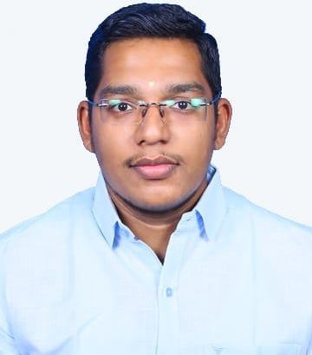
2 | 2024 | 11209D001 | R Harikrishna | B.E - Mechanical Engineering | Capgemini, Chennai | 35000/- | 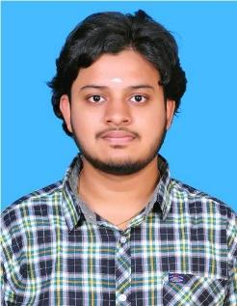
3 | 2023 | 11199D023 | Muthu Navin Maatesh | B.E - Mechanical Engineering | Arunodaya Induatries | 40000/- | 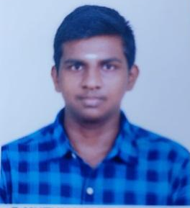
4 | 2023 | 11199D009 | Markandeya Sharma  Dharmapuri | B.E - Mechanical Engineering | Onward technologies | 50,000/- | 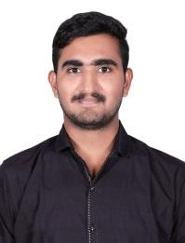
4 | 2023 | 11199D024 | P.G. NAVEEN | B.E - Mechanical Engineering | Shibaura Machines Ltd., Chennai | 40000/- | 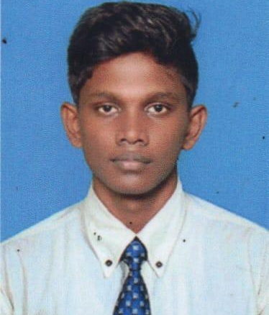
6 | 2022 | 11189D004 | Baduru Srinivas Reddy | B.E - Mechanical Engineering | Tata Consultancy Services | 30000/- | 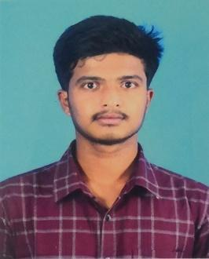
7 | 2021 | 11179D001 | Brahmanapalli Sai Kaushik | B.E - Mechanical Engineering | Promptora AI Pvt Ltd.,  Hyderabad | 80000/- | 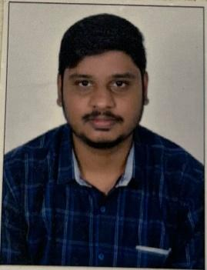
8 | 2019 | 11159D005 | Abinesh | B.E - Mechanical Engineering | Coronis IT Systems Pvt Ltd., | 65000/- | 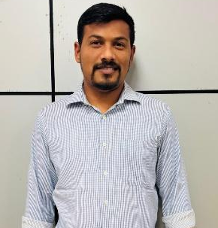
9 | 2025 | 11219H002 | CHITTALURI SAI PHANICHANDRA | B.E - Mechatronics Engineering | Svaya Robotics, Medchal, Hyderabad | 37500/- | 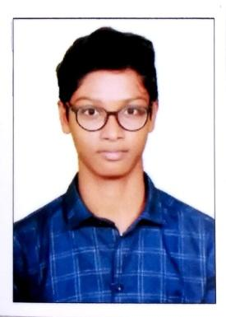

10. Outreach Activities
Industrial Visit:

S.No | Date | Industrial Visited
1 | 24/09/2025 | M/S Shibaura Machine India, PVT.LTD, Chembarambakkam, Chennai.
2 | 04/04/2025 | M/S Aditya Auto Products, Vellore
3 | 06/03/2024 | RRK Alloys, Kuppepalayam, Coimbatore.

11. Department Achievements
Awards Received: Dr. T. Rajmohan, an Associate Professor of Mechanical Engineering at SCSVMV Deemed to be University, has been recognized as one of the world’s top scientists in the global ranking produced by Stanford University in collaboration with Elsevier for the years 2021 to 2024, a prestigious achievement highlighting his significant research impact.

